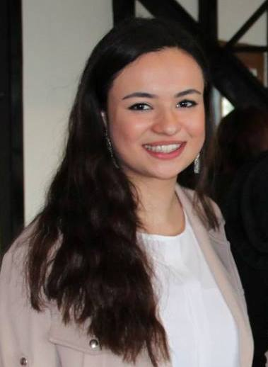 Makbule Buse Sevinç

Personal Information

Place of birth : Izmir

Date of birth : 10.04.1995

Nationality : Turkish
Mobile Phone: 0554 945 27 37
e-mail: mbusesevinc@gmail.com

Education Information

2013-2017 Yıldız Technical University

Faculty of Mechanics

Industrial Engineering

2000-2013 Izmir Ozel F. College

Physical Sciences as the Highest Honour Student

Graduation:91/100

Language Information

English : Advanced English

German : Reading, Writing, Speaking: Basic (High School and Galatasaray Uni.Course)

Computer Skills

MS Office (Excel–Word–Powerpoint-Outlook): Good, Visual Studio: Intermediate, AutoCad: Intermediate

INTERNS

P&G (Procter&Gamble) Ecommerce Sales Team Part-time

Mercedes Benz PEP Intern Marketing&Sales Department (1st August 2016- still)

Ebay Gittigidiyor.com Sales Intern Summer 2016

June-July2015 Indesit Company Production and Technology Department

August2015 Microsoft Turkey Summer School

2014-2015 Cafe Breno-Yildiz Tecnical University Brand Developer

Experiences

2016- CaseCampus Fellow-Endeavor

2015-now Turkish Woman International Network Campus Leader & Event Committee Leader

2014-2015 Cafe Breno-Yildiz Tecnical University Brand Developer

2014-2015 Ae2 Project- Team Member (made car with solar energy)

2014-2015 Elektrikport Corporate Relations Responsible

2015-YTU Woman In Business Club President

2014-2015 ESTIEM-Public Relations

2013-2015 Quality and Productivity Club Organization Team Member

2014-October ESTIEM members committee meeting in Skopje-Macedonia

2012-February COMENIUS Project-Food for thought in Vasa-Finland

Additional Information:
Projects:
- Microsoft Azure Cloud Technology
- ModernAssist- Microsoft Turkey
- www.fabrikhane.com
- Need2be mobile application
Courses:
- Financial Literacy- İş Bank
- Tubitak Entrepreneurship Programme

Memberships:

Quality and Productivity Club (QPC)

Industrial Engineering Community Association (IEC)

European Students Industrial Engineering and Management (ESTIEM)

YTU Mentoring Project

Volunteering:

Presentation to high school student:''What is the industrial engineering?''

Social Responsible Project in Club

TurkishWIN

Girişimcilik vakfı

Hobbies:
Playing tennis and violin, brisk walking, traveling, visiting museums and art galleries…

